Integration of Grafana with Jmeter

1. Download and Install Grafana
2. Configure Grafana with the database.
3. Start the server, command prompt will run and open Grafana in browser with <http://localhost:3000/>

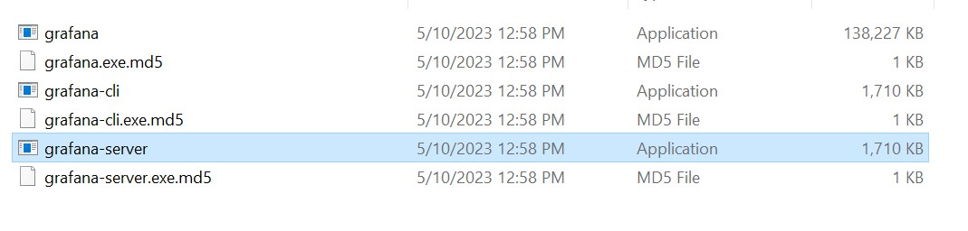

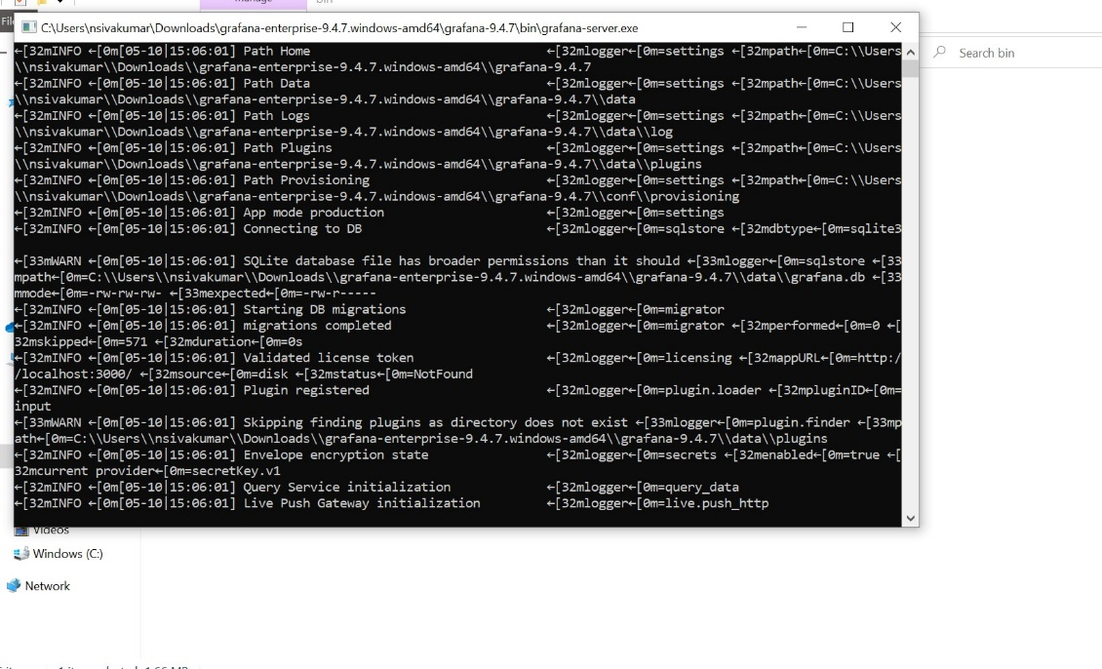

1. Login with the credentials and create data source in configuration( Setting )

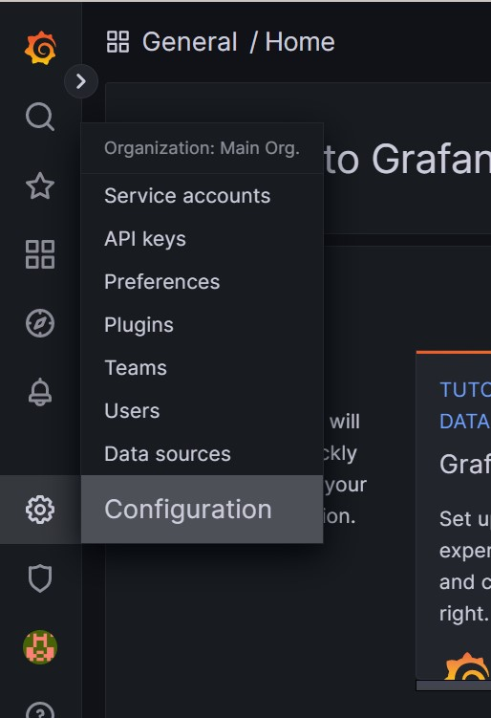

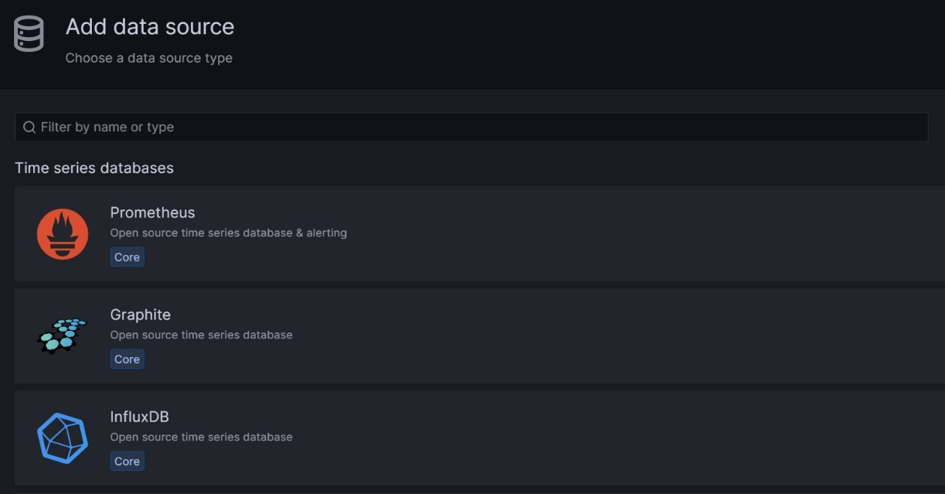

Add your database in data source.

1. Connect to your localhost to Grafana, check and fill those information.

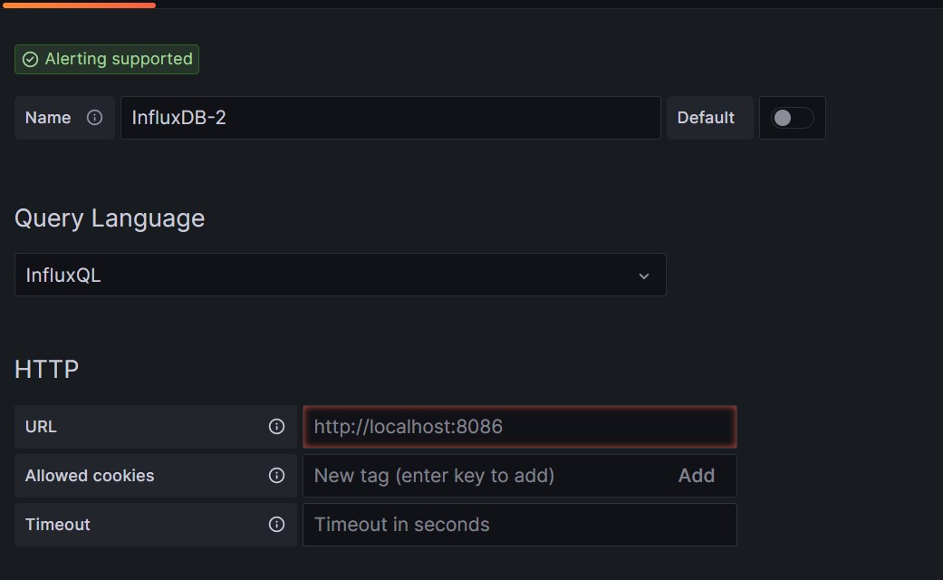

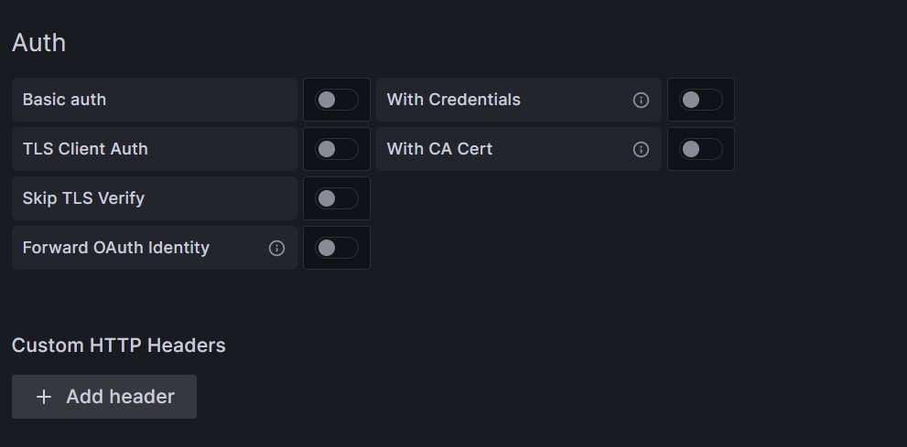

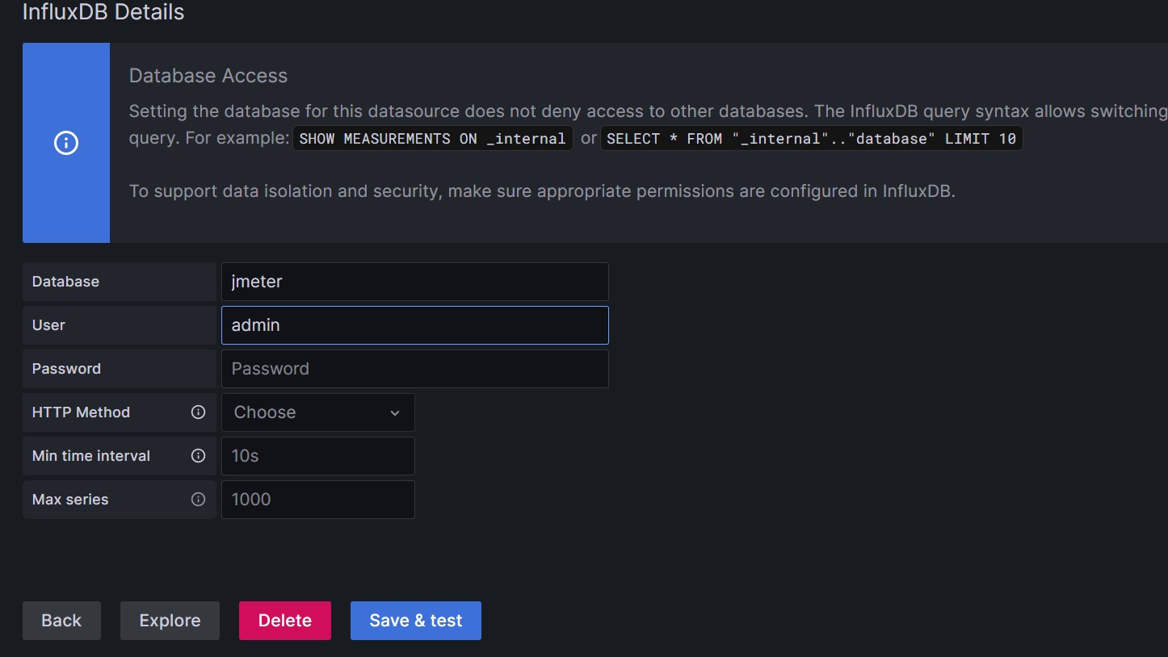

Click on Save & test to create

1. In Dashboard, import the downloaded json dashboard <https://grafana.com/grafana/dashboards/5496>

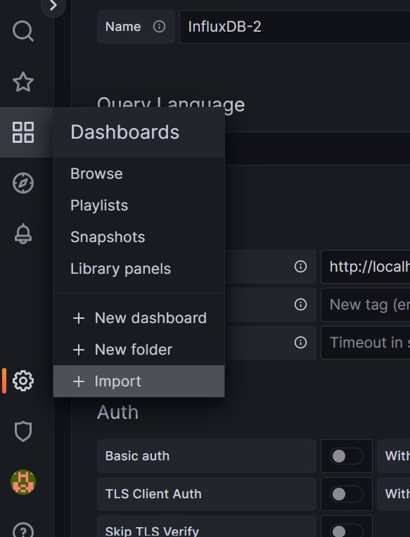

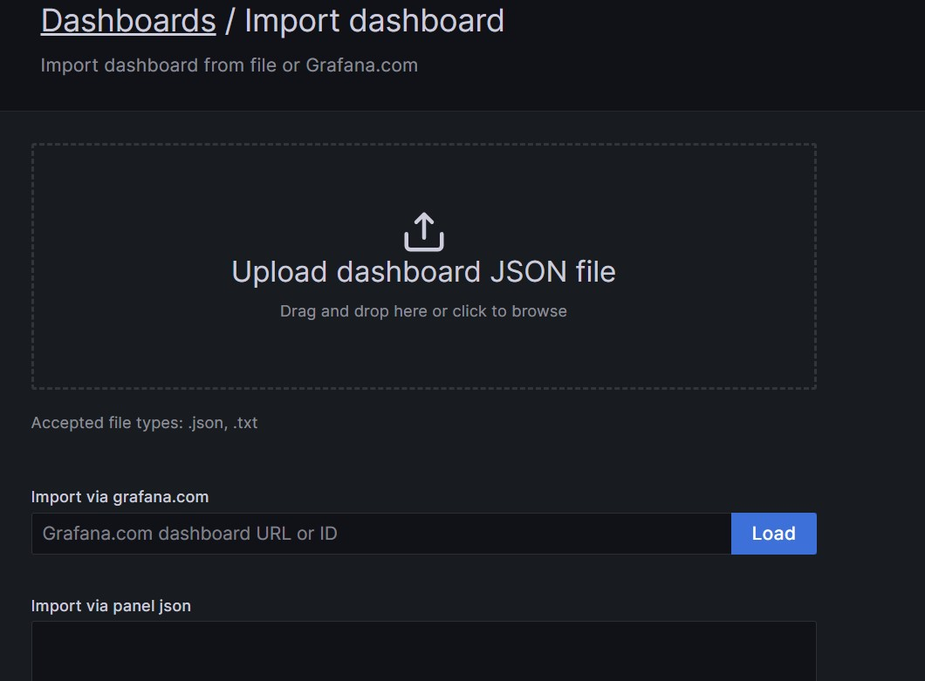

Upload dashboard

1. Open JMeter and add backend listener.

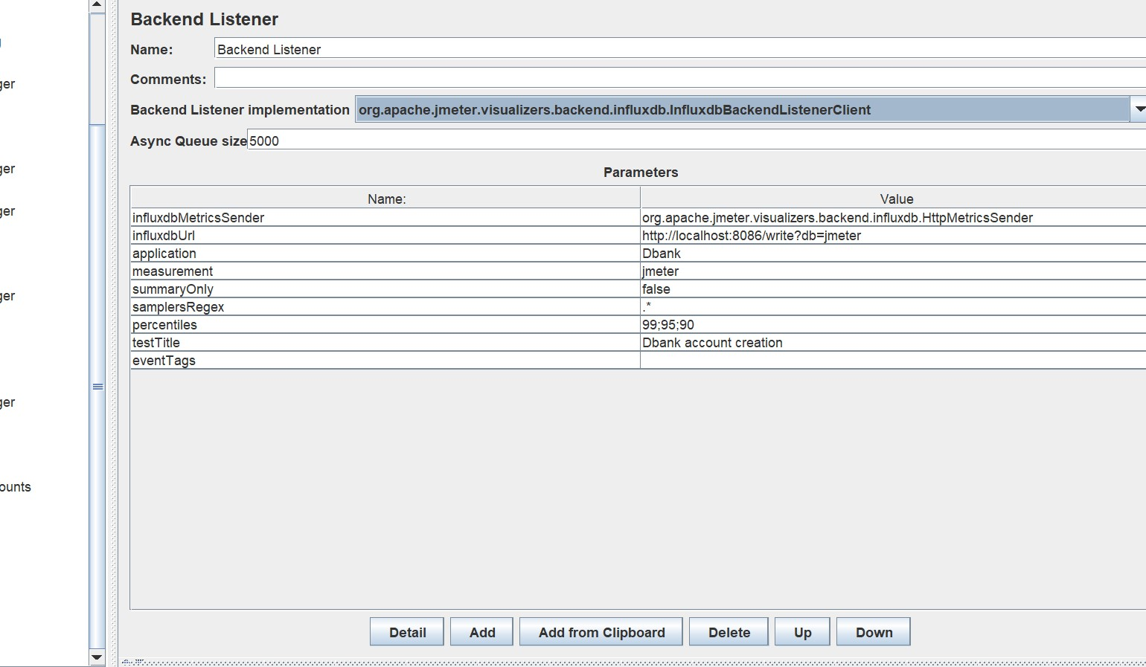

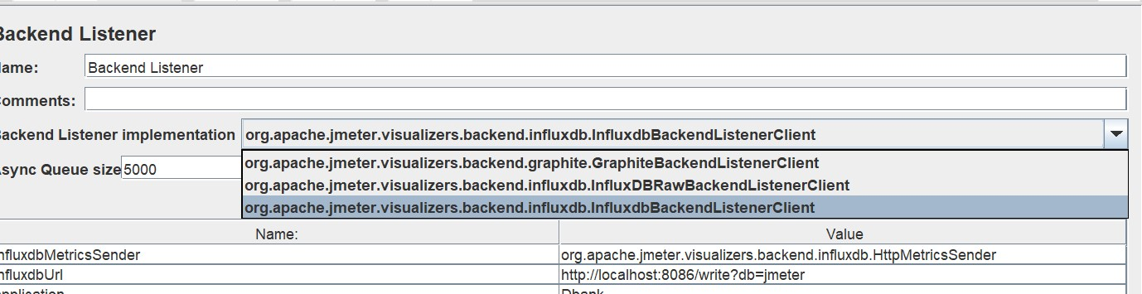

Implement the Grafana backend listener client and localhost in the url.

1. Navigate and check for the designated data source, application and transactions.

